PRACTICAL LESSON1
FIRST ANDROID APPLICATION WITH COMMENTS

Here is demonstrated an application with three buttons and two activities. The structure of the project is given on the next figure

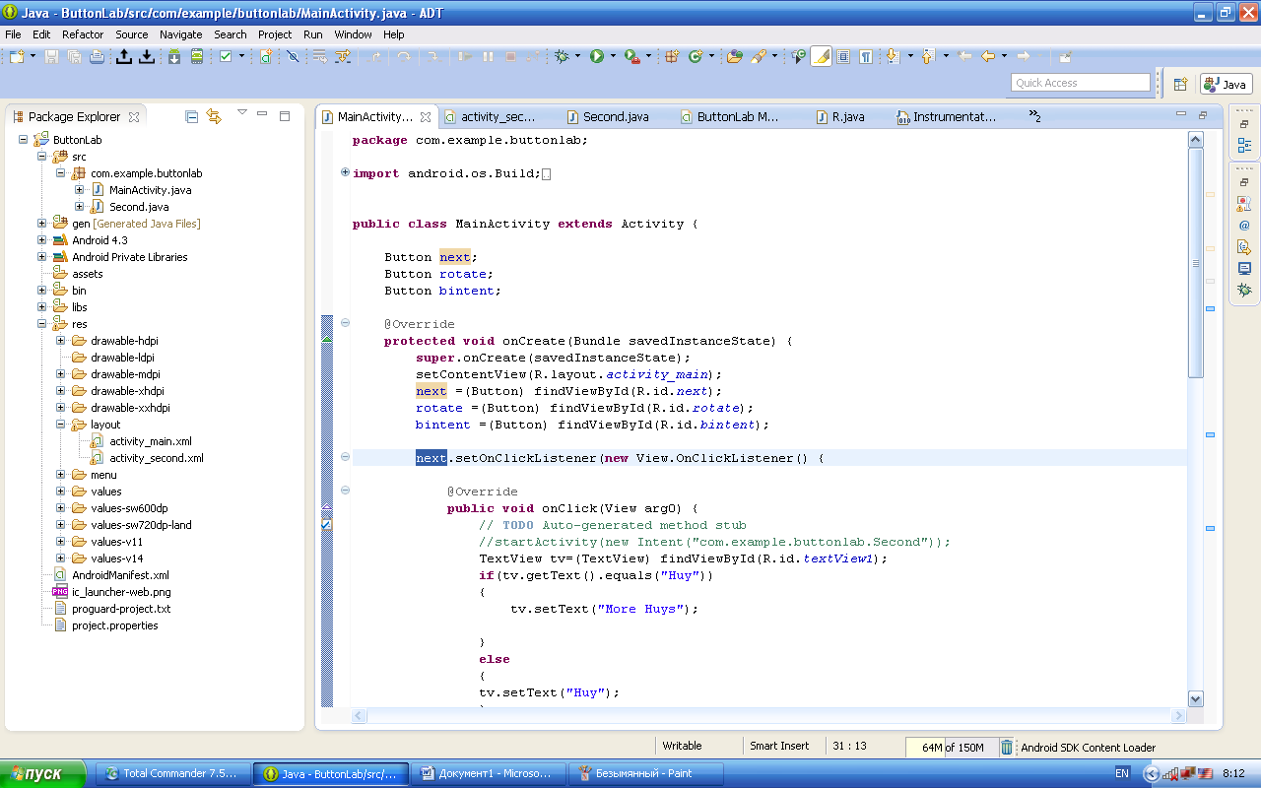
The application main parts are activities, layouts and AndroidManifest.xml.
The main activity MainActivity.java has the next form:
package com.example.buttonlab;

import android.os.Build;
import android.os.Bundle;
import android.animation.ObjectAnimator;
import android.animation.ValueAnimator;
import android.annotation.SuppressLint;
import android.annotation.TargetApi;
import android.app.Activity;
import android.view.Menu;
import android.content.Intent;
import android.view.View;
import android.widget.Button;
import android.widget.TextView;

public class MainActivity extends Activity {

Button next;
Button rotate;
Button bintent;

@Override
protected void onCreate(Bundle savedInstanceState) {
super.onCreate(savedInstanceState);
setContentView(R.layout.activity_main);
next =(Button) findViewById(R.id.next);
rotate =(Button) findViewById(R.id.rotate);
bintent =(Button) findViewById(R.id.bintent);

next.setOnClickListener(new View.OnClickListener() {

@Override
public void onClick(View arg0) {
// TODO Auto-generated method stub
//startActivity(new Intent("com.example.buttonlab.Second"));
TextView tv=(TextView) findViewById(R.id.textView1);
if(tv.getText().equals("Hy"))
{
tv.setText("More Hys");

}
else
{
tv.setText("Hy");
}
}
});

bintent.setOnClickListener(new View.OnClickListener() {

@Override
public void onClick(View v) {
// TODO Auto-generated method stub
//startActivity(new Intent("com.example.buttonlab.Second"));
Intent lg=new Intent(MainActivity.this,Second.class);
startActivity(lg);
}
});

rotate.setOnClickListener(new Button.OnClickListener() {

@TargetApi(Build.VERSION_CODES.HONEYCOMB)
@SuppressLint("NewApi")
@Override
public void onClick(View v) {
// TODO Auto-generated method stub
//startActivity(new Intent("com.example.buttonlab.Second"));
ValueAnimator va=ObjectAnimator.ofFloat(rotate,
"rotation", 0f,360f);
va.setDuration(750);
va.start();

}
});

}

@Override
public boolean onCreateOptionsMenu(Menu menu) {
// Inflate the menu; this adds items to the action bar if it is present.
getMenuInflater().inflate(R.menu.main, menu);
return true;
}

}

In this activity three buttons are declared:
Button next;
Button rotate;
Button bintent;

Then each button is created and assigned an onClick method, e.g.

next =(Button) findViewById(R.id.next);
rotate =(Button) findViewById(R.id.rotate);
bintent =(Button) findViewById(R.id.bintent);

next.setOnClickListener(new View.OnClickListener() {

@Override
public void onClick(View arg0) {
// TODO Auto-generated method stub
//startActivity(new Intent("com.example.buttonlab.Second"));
TextView tv=(TextView) findViewById(R.id.textView1);
if(tv.getText().equals("Hy"))
{
tv.setText("More Hys");

}
else
{
tv.setText("Hy");
}
}
});

Here an example of the next button is given. In the treatment procedure the content of the TextView is taken and analyzed with the necessary reactions by if .. then … block. When the project is running the following window appears

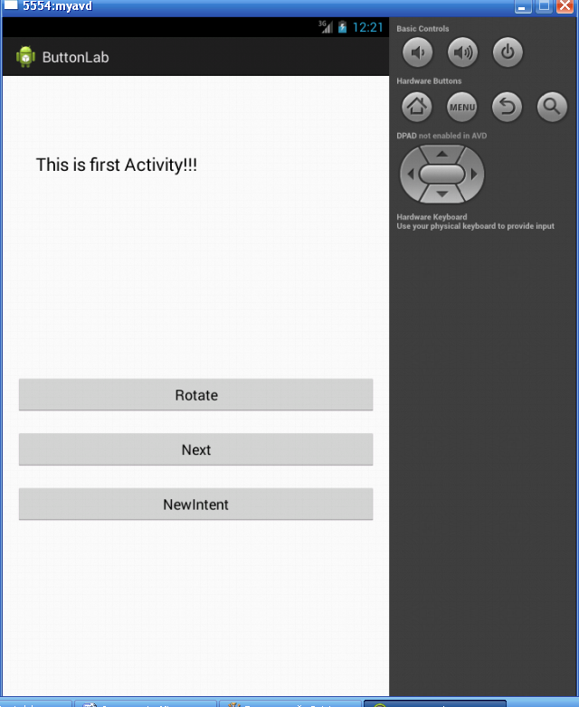

This window is defined in the corresponding layout-file (activity_main.xml) in the res folder. The following is its content
ACTIVITY MAIN.xml
<LinearLayout xmlns:android="http://schemas.android.com/apk/res/android"
xmlns:tools="http://schemas.android.com/tools"
android:layout_width="fill_parent"
android:layout_height="fill_parent"
android:paddingBottom="@dimen/activity_vertical_margin"
android:paddingLeft="@dimen/activity_horizontal_margin"
android:paddingRight="@dimen/activity_horizontal_margin"
android:paddingTop="@dimen/activity_vertical_margin"
android:orientation="vertical"
tools:context=".MainActivity" >

<TextView
android:id="@+id/textView1"
android:layout_width="wrap_content"
android:layout_height="200dp"
android:layout_alignParentLeft="true"
android:layout_alignParentTop="true"
android:layout_marginLeft="25dp""res/layout/activity_main.xml"
android:layout_marginTop="78dp"
android:text="This is first Activity!!!"
android:textAppearance="?android:attr/textAppearanceLarge"

/>

<Button
android:id="@+id/rotate"
android:layout_width="fill_parent"
android:layout_height="wrap_content"
android:layout_alignParentLeft="true"
android:layout_alignParentBottom="true"
android:layout_marginBottom="20dp"
android:text="Rotate"
android:layout_marginTop="78dp"
/>

<Button
android:id="@+id/next"
android:layout_width="fill_parent"
android:layout_height="wrap_content"
android:layout_alignParentLeft="true"
android:layout_alignParentBottom="true"
android:layout_marginBottom="20dp"
android:text="Next"
/>

<Button
android:id=”@+id/bintent”
android:layout_width=”fill_parent”
android:layout_height=”wrap_content”
android:layout_alignParentLeft=”true”
android:layout_alignParentBottom=”true”
android:layout_marginBottom=”20dp”
android:text=”NewIntent”
/>

</LinearLayout>

The screen layout configuration is defined with the help of layout dispatcher (LinearLayout here). First, the common descriptions follow:
<LinearLayout xmlns:android="http://schemas.android.com/apk/res/android"
xmlns:tools="http://schemas.android.com/tools"
android:layout_width="fill_parent"
android:layout_height="fill_parent"
android:paddingBottom="@dimen/activity_vertical_margin"
android:paddingLeft="@dimen/activity_horizontal_margin"
android:paddingRight="@dimen/activity_horizontal_margin"
android:paddingTop="@dimen/activity_vertical_margin"
android:orientation="vertical"
tools:context=".MainActivity" >

One of the most important is android:orientation="vertical"
as it defines that widgets are placed one under the one.
Consider, for instance the next fragment concerning a button widget:
<Button
android:id="@+id/next"
android:layout_width="fill_parent"
android:layout_height="wrap_content"
android:layout_alignParentLeft="true"
android:layout_alignParentBottom="true"
android:layout_marginBottom="20dp"
android:text="Next"
/>

It describes the next button. The width of the button rectangle occupies all the mobile screen diapason (android:layout_width="fill_parent"). Also, the alignment tags are presented providing layout formatting. Please, pay attention to the widget identifier
android:id="@+id/next"
as it is used in the code of the corresponding activity.

Now return to the main activity and consider how the button NewIntent is used to show the second activity screen:

bintent.setOnClickListener(new View.OnClickListener() {

@Override
public void onClick(View v) {
// TODO Auto-generated method stub
//startActivity(new Intent("com.example.buttonlab.Second"));
Intent lg=new Intent(MainActivity.this,Second.class);
startActivity(lg);
}
});

The most important is the next line here
Intent lg=new Intent(MainActivity.this,Second.class);
It creates an intent (interface between two activities). Then we simply start this intent by
startActivity(lg);

This second activity screen is as below

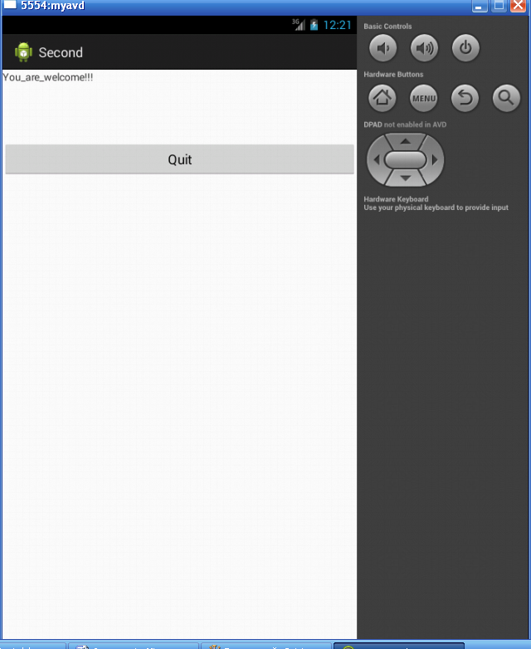

The corresponding layout file has the following content:
ACTIVITY SECOND.xml
<?xml version="1.0" encoding="utf-8"?>
<LinearLayout xmlns:android="http://schemas.android.com/apk/res/android"
xmlns:tools="http://schemas.android.com/tools"
android:layout_width="match_parent"
android:layout_height="match_parent"
android:orientation="vertical">

<TextView
android:layout_width="wrap_content"
android:layout_height="wrap_content"
android:text="You_are_welcome!!!" />

<Button
android:id="@+id/bfinish"
android:layout_width="fill_parent"
android:layout_height="wrap_content"
android:layout_alignParentLeft="true"
android:layout_alignParentBottom="true"
android:layout_marginBottom="20dp"
android:text="Quit"
android:layout_marginTop="78dp"
/>

</LinearLayout>

As one can see there are two widgets: TextView and Button here. Below we place the code of the second activity:

package com.example.buttonlab;

import android.os.Bundle;
import android.app.Activity;
import android.view.Menu;
import android.view.View;
import android.widget.Button;
import android.widget.TextView;

public class Second extends Activity {

Button bfin;

@Override
protected void onCreate(Bundle savedInstanceState) {
super.onCreate(savedInstanceState);
setContentView(R.layout.activity_second);

bfin =(Button) findViewById(R.id.bfinish);

bfin.setOnClickListener(new View.OnClickListener() {

@Override
public void onClick(View arg0) {
// TODO Auto-generated method stub
//startActivity(new Intent("com.example.buttonlab.Second"));
finish();
}
});

}

@Override
public boolean onCreateOptionsMenu(Menu menu) {
// Inflate the menu; this adds items to the action bar if it is present.
getMenuInflater().inflate(R.menu.second, menu);
return true;
}

}

The button bfinish is used simply to close (finish) the second screen and return to the main screen.
At the last we present a manifest file defining the structure of the whole project

Файл –манифест
<?xml version="1.0" encoding="utf-8"?>
<manifest xmlns:android="http://schemas.android.com/apk/res/android"
package="com.example.buttonlab"
android:versionCode="1"
android:versionName="1.0" >

<uses-sdk
android:minSdkVersion="8"
android:targetSdkVersion="18" />

<application
android:allowBackup="true"
android:icon="@drawable/ic_launcher"
android:label="@string/app_name"
android:theme="@style/AppTheme" >
<activity
android:name="com.example.buttonlab.MainActivity"
android:label="@string/app_name" >
<intent-filter>
<action android:name="android.intent.action.MAIN" />

<category android:name="android.intent.category.LAUNCHER" />
</intent-filter>
</activity>
<activity
android:name="com.example.buttonlab.Second"
android:label="@string/title_activity_second" >
<intent-filter>
<action android:name="android.intent.action.VIEW" />

<category android:name="android.intent.category.DEFAULT" />
</intent-filter>
</activity>
</application>

</manifest>

Each activity has the corresponding tag-definition here. Please, pay attention to the <intent-filter> tag as it is used to provide communication linkage between two activities.

